DNA vs RNA

DNA: (deoxyribonucleic acid) information molecule that is the universal basis of an organisms genetic material; contains instructions, written in chemical code, for the production of proteins by the cell

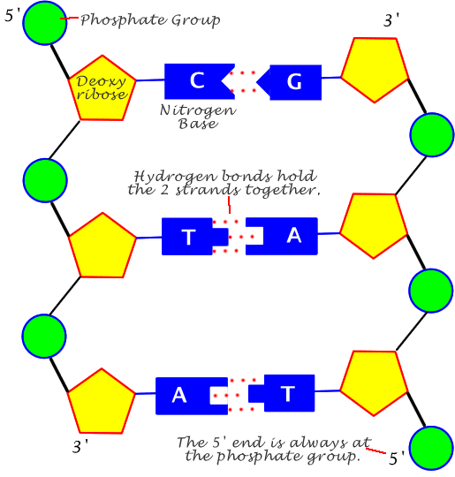RNA: (ribonucleic acid) molecule consisting of a single strand of nucleotides; essential role in protein synthesis

|  |  |
| --- | --- |
| DNA | RNA |
| Double helix | Single helix |
| Adenine, thymine, cytosine, guanine | Adenine, uracil, cytosine, guanine |
| Found in nucleus and mitochondria | Found in nucleus, cytoplasm, and ribosomes |
| Self-replicating | Synthesized from DNA when needed |

Cells

Each cell originates from another cell

Cells undergo division: mitosis, binary fission, meiosis

Asexual reproduction: a form of reproduction that in which offspring are produced from a single parent

Sexual reproduction: a form of reproduction that in which offspring are produced from two parents

Eukaryote DNA

* Complex cells containing membrane-bound organelles
* DNA is found in the nucleus and mitochondria, chloroplasts in plants
* During cell division, DNA can be seen as a chromosome
* Chromosomes come in pairs (inherited from each parent) in humans, somatic cells (body cells) have 1 pair (autosomes (XX female, XY male))
* Karyotypes can be used to assess an organisms DNA (ordered in length (largest to smallest) in pairs)
* Cells in the body of sexually producing organisms are:
  + Somatic (body): diploid, mitosis
  + 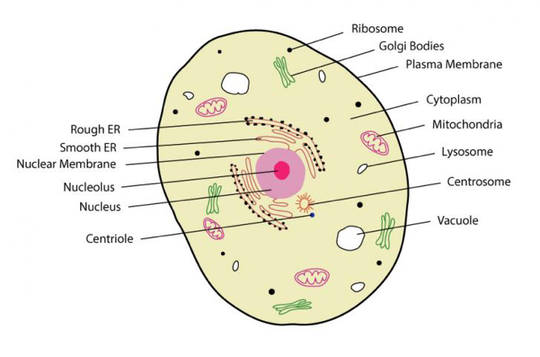Gametes (sex): haploid, meiosis

Prokaryote DNA

* Organisms that do not have membrane-bound organelles
* DNA forms a single circular chromosome
  + In direct contact with cytoplasm (not in a nucleus)
  + May be in a specific region known as a nucleoid
  + Other rings known as plasmid may be present, can replicate independently to main chromosome
* DNA coils and proteins fold to condense size
  + Most do not contain histones
* Haploid
* Very little repetitive non-coding DNA
* 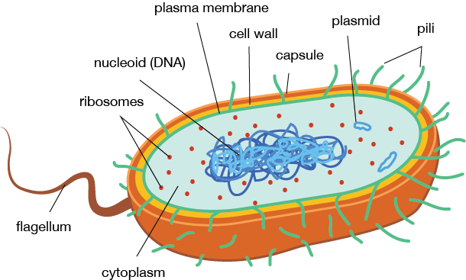Rarely, some bacteria will contain 1+ chromosome

Genes

* Genes is a region on a DNA molecule that codes for a particular protein and trait
* Locus is a specific location of a gene on the DNA molecule
* Homologous chromosomes will have the same loci for genes
* Alleles are alternative versions of the same gene (eg: eye colour)

Cell Cycle

Eukaryotic cells use mitosis and cytokinesis (cytoplasmic division)

* Form two diploid daughter cells (identical set of chromosomes)

Meiosis is eukaryotic cell division concerned with the production of gametes and occurs in sex cells

* Results in four daughter cells, contains half the number of chromosomes (haploid)
* At fertilisation, two haploid gametes combine to from a diploid zygote

The cell cycle

* Interphase
  + Active growth (G1 phase)
  + Undergoing extended G1 but not preparing to replicate DNA and divide (G0) withdrawn from the active cell cycle
  + Synthesis of DNA (S phase)
  + Preparation for next division (G2 phase)
* Nuclear division (M phase)
* Cytokinesis (C phase)
* Phases can be identified by measuring the changes in a cell volume or in the amount of nuclear DNA

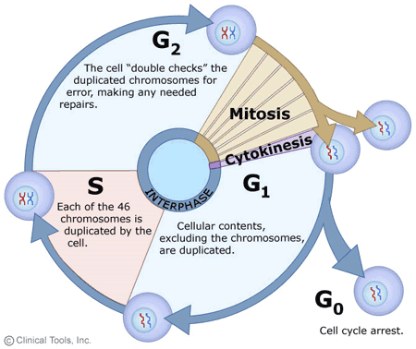

Mitosis

For growth and repair

1. **I**nterphase
2. **P**rophase
3. **M**etaphase
4. **A**naphase
5. **T**elophase

Interphase

* Chromosomes aren’t seen
* DNA replicates
* Cell spears to be the same non-dividing cell
* Sometimes not considered to be as important

Prophase

* Chromosomes shorten and thicken and become visible
* Form chromatids
* Nucleus membrane breaks down
* Nucleus shrinks
* Centrioles move to opposite ends
* Spindle fibres begin to form

Metaphase

* Chromosomes line up across the centre of the cell
* Spindle fibres extend and attach to centromeres
* Chromatid may begin to separate

Anaphase

* Chromatids move to opposite ends of the cell along spindle fibres

Telophase

* Spindle fibres degenerate
* Then slight differences in each animals and plant cells
* Animals:
  + Cell membrane begins to split
  + Nuclear membrane and nucleolus reform
* Plants:
  + Cell plate is formed
  + Cell wall and membrane formed along cell plate to give two new cells

Cytokinesis

* Not apart of mitosis
* 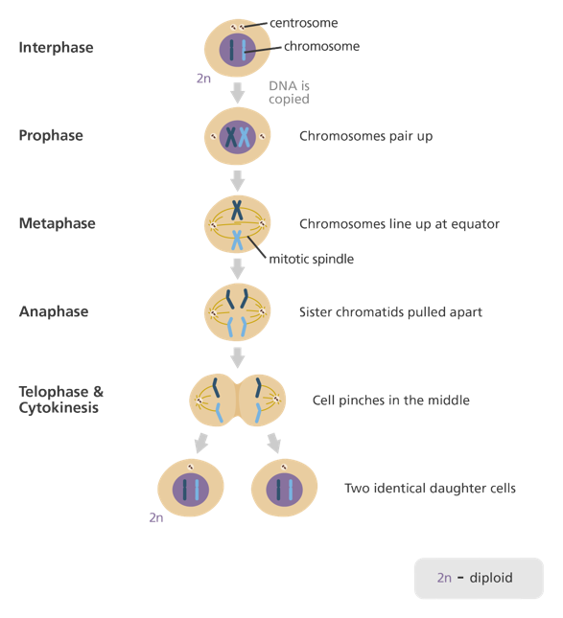The division of the cytoplasm to produce two identical daughter cells

Meiosis

Cell division of germ (sex) cells

Occurs in sex organs eg: ovaries

Two nuclear divisions occur with only one chromosome replication

Parent cells are diploid in number but each produces four haploid daughter cells

Gametes show some variation due to crossing over and mutations

Phases:

* 8 phases (interphase not included in meiosis)
* Goes through each phase twice

Interphase

* Resting phase
* Chromosomes start to duplicate
* Chromosomes become a pair of chromatids attached at the centromere

Prophase 1

* DNA has already replicated
* Chromosomes shorten, thicken and become visible
* Homologous chromosomes pair up and lie side by side forming tetrads (or bivalents)
* Centrioles separate and move to poles
* Nuclear membrane disappears
* Spindles form supporting chromatids
* Some crossing over occurs and genetic materials exchanged between homologous chromosomes
* May take days to complete

Crossing over: Prometaphase

* This is when a section of one chromosome switches place with the same section (chiasmata) from the other chromosome of the pair

Metaphase 1

* Tetrads align across the equator
* Held by spindle fibres attached to the centromere and centrioles at the poles
* Random assortment of the homologous pairs occur

Random/independent assortment

* Chromosomes are sorted randomly when they line up along the equator and are pulled apart by the spindle fibres

Anaphase 1

* Spindles pull chromosomes to poles at the centromere
* Unlike in mitosis, the homologous chromosomes move to opposite poles yet the sister chromatids remain together

Telophase 1

* Spindle fibres breakdown
* Nuclear membrane reforms
* Cell divides into two and each undergo a second division (cytokinesis)
* Two haploid daughter cells form

Prophase 2

* Similar to prophase 1, but no replication

Metaphase 2

* Chromosomes line up singularly across centre of cell

Anaphase 2

* Chromosomes separate at centromeres
* Chromatids pulled apart and move to opposite poles

Telophase 2

* Nuclear membrane reforms
* Spindle fibres dissolve
* Cell divides (cytokinesis)
* 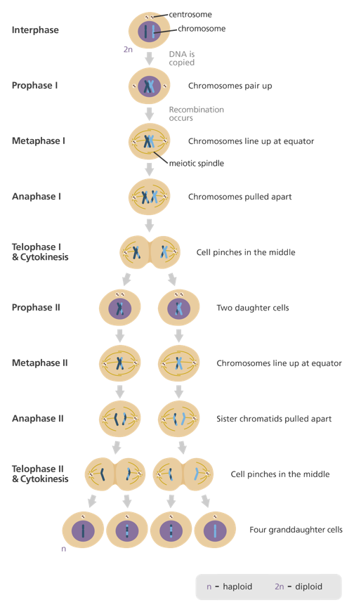Four haploid daughter cells

Binary fission

The division of a cell into two without mitosis

* One chromosome, replicates, attaches itself to cell membrane where cell starts to divide, separating the replica and original into two different cells

|  |  |
| --- | --- |
| Binary fission | Mitosis |
| One chromosome, no centromere | Many chromosomes with centromere |
| DNA replication | DNA replication |
| Produces two identical daughter cells | Produces two identical daughter cells |
| Chromosome segregation | Chromosome segregation |
| Cytokinesis | Cytokinesis |
| Occurs in prokaryotes and eukaryotic organelles | Occurs in eukaryotic cells |

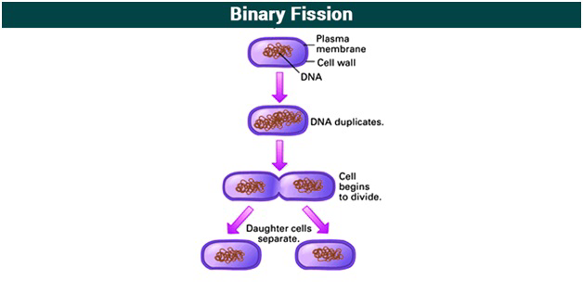

DNA replication

Producing an exact copy of original DNA molecule for cell division

DNA is antiparallel 3’ and matches with 5’ end

Two ends of DNA:

* 5 prime (5’) end (phosphate group -PO4)
* 3 prime (3’) end (hydroxide group -OH)

Leading strand: parent strand, runs 3’ to 5’ direction towards fork, replicates constantly

Lagging strand: parent strand, runs in 5’ to 3’ direction towards fork, replicates discontinuously

Enzymes involved are

* DNA helicase
* DNA polymerase
* DNA ligase

1. Replication fork formation
   * DNA is ‘unzipped’ using helicase
   * Helicase used to split and unwind the strands of DNA(breaks hydrogen bonds)
   * Forms a Y shape fork
   * Single-stranded binding proteins (SSB’s) join nucleotides to prevent DNA re-joining
2. Primer binding
   * Short piece of RNA (‘primer’) binds to 3’ end (staring point), generated by DNA polymerase
3. Elongation
   * DNA polymerase creates a new strand (‘elongation’)
   * Leading strand is continuous
   * Lagging strand is discontinuous
   * DNA polymerase has to wait for RNA primer before it can start
   * DNA polymerase adds pieces of DNA to lagging strand known as Okazaki Fragments
4. Termination
   * Exonuclease removes primers and ‘proof reads’ DNA
   * DNA ligase joins Okazaki Fragments into a continuous line

DNA replication is semiconservative because 1 side was original, 1 side made

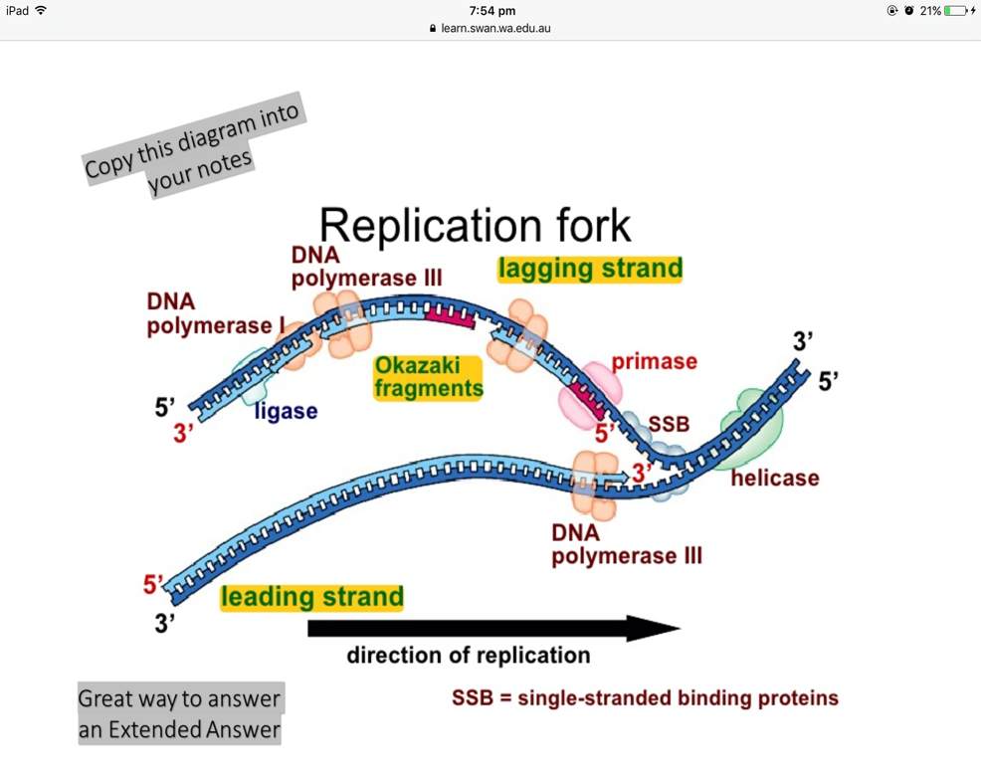Single-stranded binding proteins holds strands ‘open’ for replication

Protein synthesis

RNA

* 3 types of RNA
  + mRNA is the ‘blueprint’ for construction of a protein (messenger)
  + rRNA is the ‘construction site’ where the proteins are made (it’s a ribosome) (ribosomal)
  + tRNA is the ‘truck’ delivering the proper amino acids to the site of protein synthesis (transfer)

Genes and proteins

* Genes are a sequence of nucleotides in DNA that code for a particular protein
* Proteins drive cellular processes, determine physical characteristics, and manifest genetic disorders by their absence or presence

Genetic code

* Proteins are composed of 20 different amino acids
* A sequence of 3 nucleotides is used to code for each amino acid
* Each triplet of nucleotides is called a codon
* Start codon AUG codes for amino acid methionine
* 3 stop codons (no corresponding amino acids)
* There are 64 codons in the genetic code
* Several different codons can code for the same amino acid, but no codon ever has more than one amino acid counterpart

Transcription: Initiation

* RNA polymerase binds to a segment of DNA and opens up the double helix
* The template strand is read in a 3’-5’ direction from a start codon to a stop codon

Transcription: Elongation

* The RNA polymerase uses inly one strand of DNA as a template for mRNA synthesis
* Coding strand contains the complementary RNA molecule sequence to the template strand
* RNA polymerase can add nucleotides only to the 3’ end of a DNA sequence
* RNA molecule elongates in the 5’ to 3’ direction

Transcription: Termination

* RNA polymerase leaves the gene, a new RNA polymerase can bind there to begin a new mRNA strand
* Since prokaryotes lack a membrane bound nucleus translation can begin even before the mRNA leaves the DNA

mRNA splicing

* mRNA contains base sequences that are not translated into codons: introns
* base sequences that are translated into codons: exons
* introns are removed while the exons are spliced together
* INtrons stay IN the nucleolus, Exons EXIT the nucleolus

Translation

* mRNA exits the nucleus via nuclear pores and ribosomes bind to mRNA
* ribosomes synthesise different proteins by reading the coding sequences on mRNA
* The mRNA is read in the triplets of nucleotides each of which encodes an amino acid

Transfer RNA

* Transfer RNA (tRNA) delivers amino acids to the ribosome
* At the end of one lobe of tRNA a sequence of 3 bases called anti-codon recognises and is complementary to the codon of the mRNA
* 3’ end is attached site for amino acid

Ribosomes

* Ribosomes are the site of protein synthesis
* Complex that contains a cluster of different kinds of proteins and rRNA
* Made of 2 subunits (larger and smaller)
* Made from rRNA and proteins by the nucleolus
* Ribosome had binding sites for the mRNA and the tRNA molecules
* Multiple codons for amino acids to reduce risk of mutation

Termination of protein synthesis

* Translation continues until the stop codon on the mRNA is reached
* Stop codons do not code for an amino acid, there are no corresponding tRNA’s
* This causes the polypeptide to separate from the ribosome
* Ribosomes fall of the mRNA and translation stops

Proteins

3D – unique

Primary structure: string of amino acids (polypeptide bonds)

Secondary structure: double helix and pleated polypeptide becomes folded

Tertiary structure: secondary structure fold into complex shape

Quaternary structure: multiple tertiary structures come together complete and functional proteins

Gene expression

Cells do not express all genes in their genome at the same time or same rate

Active and inactive genes (specific and unnecessary proteins)

Controls with how fast the genes are transcribed, depending on development and conditions around the cell

Exons (or exome) coding, vast majority is non-coding (introns)

Gene expressions regulation

* Gene expression: gene is transcribed into mRNA and translated into a protein
* Gene regulation: process within a cell that enables gene to be expressed in the cell at a specific times
* Non-coding genes may have a specific function in switching on or off gene expression ‘off’ genes are in a chromatin state, where RNA polymerase cannot access

Chemical influences

* Methylation: some cytosine nitrogenous bases had a methyl group attached, and was unable to be turned on. When these genes were active, they did not have the methyl group attached
* Imprinting: gene silencing. One of 2 alleles are silenced
* Epigenetics: chemical signatures altered by environmental factors passed on through germ line
* Regulatory proteins, activators and enhancer regions

Genetic variation

* Dominant and recessive alleles
* Mutations
* Crossing over and random assortment
* Gene interactions

Environmental variation

* Climate and altitude
* Water availability
* Acidity (pH)
* Soil type
* Light
* Predation
* Competition

Temperature

* Colour point animals produce a pigment in the cooler areas of their body (eg: ears, paws, face) that result in darker spots
* Some animals don’t undergo meiosis and rely on temperature to determine the sex of the offspring (eg: turtles) this reduces interbreeding because the whole group is the same gender typically

Other organisms

* Water flea will grow a helmet for protection in response to the presence of midge larvae
* Wrasse fish, when dominant male dies, dominant female changes into a male

Altitude and chemical environment

* Altitude can stunt phenotype of plants with the same genotype (eg: conifers will stunt in growth as altitude increases. This is known as a cline)
* Acidity of soil can cause a change in organisms (hydrangeas will change to blue in high pH, pink in low pH soil)

Genotype + Environment = Phenotype

Mutations

Mutations are permanent changes to the DNA

Often affects translated proteins they code for

Subtle, or severe (rarely will benefit)

Effect dependent on whether the mutation affects somatic or gamete cells

Mutagens:

* Physical and chemical
* Physical various type of radiation (eg: UV light), increased risk of skin cancer
* Causes double-stranded breaks + complete breaks in the chromosome

|  |  |
| --- | --- |
| Physical mutagen | effect |
| UV light | Structural distortion by cross-linking neighbouring nucleotides |
| X-ray | Gene chromosome aberrations |
| Nuclear Radiation | Breaks in DNA strands |

* Chemical mutagens often results in the substituting the base for another (eg: 5 bromouracil replaces thymine)
* Can change the structure of the existing nitrogenous bases (eg: replacing C-G with A-T)
* Leads to less or double of nucleotide

Point mutations

* Single nucleotide polymorphisms: differences between sequences in the nucleotides of one position

Substation

* One nucleotide is replaced by another
* Number of possibilities of effect on translated protein

|  |  |
| --- | --- |
| Silent mutation | Occurs when substituted base results in a codon that codes for the same amino acid as the original codon |
| Missense mutation | Single nucleotide changes the amino acid (eg: AGA > AGC = serine AA, instead of arginine) |
| Nonsense mutation | Creates a new stop codon within original gene sequence, leading to early termination (produce an incomplete polypeptide) |

Insertion and deletions

* Insertion: addition of 1 or more nucleotides
* Deletion: loss of nucleotide from site
* Affect results in frameshift where the reading frame for amino acids are nudged away fom original
* All codons down steam are affected

Other mutations

* Neutral mutations: protein product is unchanged compared with the original
  + Can be missense substitutions
* Deleterious mutations: mutations that disrupt the function of the protein, affecting the whole organism
  + Typically nonsense mutations
* Beneficial mutations: mutation that leads to the generation of a new allele that benefits the organism eg: some people have developed a resistance to HIV infection (nonsense mutation)

Chromosomes

* Variations in chromosome number: monoploidy, polyploidy, aneuploidy
* Variations in chromosome structure: deletions, inversion, translocation, duplications
* Non-disjunction: failure to separate during meiosis, results in abnormal number of chromosomes in sex cells

|  |  |
| --- | --- |
| Chromosome number | definition |
| Monoploidy | 1 chromosome 1n (eg: ants) |
| Polyploidy | Cell division can go wrong, resulting in fused diploid and haploid cells -3n and 4n (eg: flowering plants) lethal in humans |
| Aneuploidy | Condition where there is an addition or loss of chromosome from a cell (2n+1 or 2n-1) |

Chromosomal mutations

* 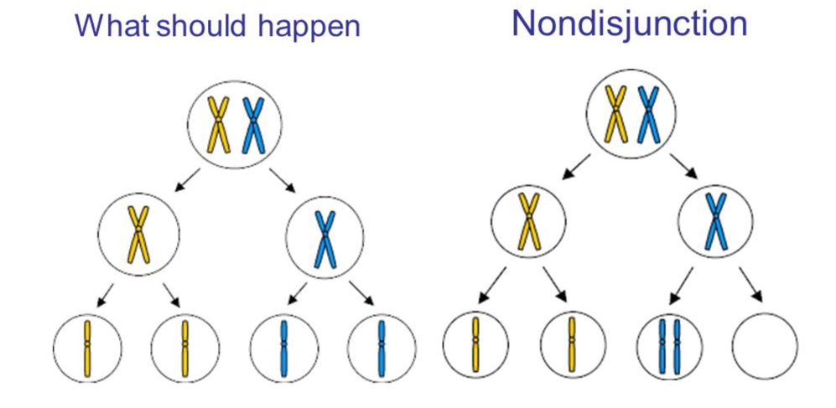Nondisjunction

|  |  |
| --- | --- |
| Deletion | Double stranded breaks at two points, section between may drop out, if the two sections re-join, result in smaller chromosomes, usually fatal |
| Inversion | Section of chromosome breaks, section in the idle rotates 180o, reverse the normal sequence of genes, less dramatic consequences, can reduce fertility |
| Translocation | Section of one chromosome breaks off and reattaches to another chromosome, normal control over genes in that segment is lost (results in a form of cancer) |
| Duplication | Extra copy is made of a section of a chromosome and inserted into the same chromosome, can change the number of particular genes, can be advantageous |

Biotechnology

Biotechnology: describes the us of living things to make new products or systems to benefit humans

Eg: glofish = the green fluorescent protein (GFP) gene from jellyfish was inserted into a zebra fish, causing it to glow green

Includes a range of techniques – switching genes on and off, removing genes, introducing genes from one species to another

Been used for ages, Egyptians used yeast for beer, bread and wine, selective breeding

Modern Biotechnology

* Genetic engineering: manipulating the outcome of normal functioning genes; changing genetic sequence of organisms through human use of biotechnology techniques
* Produces genetically modified organisms (GMOs/transgenic organisms)

Restriction enzymes

* Restriction enzymes are enzymes used to cut pieces of DNA (DNA is too small for a mechanical tool)
* Enzymes typically attained from bacteria (used for defence) and are named after the bacteria they are derived from
* Cuts at specific recognition site on DNA
* Recognition site: site on DNA with specific code that activates enzyme

1. Sequence DNA (scientist will determine the bases pattern of DNA)
2. Find restriction enzyme for recognition site matches DNA bases)
3. Add restriction enzyme to either side of the DNA (reads 3’ to 5’)
4. DNA piece splits (weak hydrogen bonds)
5. Creates ‘blunt’ ends and ‘sticky’ ends

(blunt ends not exposed nucleotides, not useful to scientist, sticky ends expose nucleotides, overhangs, useful to scientist)

Action of ‘sticky end’ restriction enzymes

1. A restriction enzyme cuts the double-stranded DNA molecule at its specific recognition site
2. The cut produces a DNA fragment with two ‘sticky’ ends. The piece it is removed from is also left with ‘sticky’ ends
3. When two such fragments of DNA cut by the same restriction enzyme come together they can join by base pairing. This can allow DNA fragments from a different source, perhaps a plasmid, to be joined to the initial fragment
4. The fragments of DNA are joined together by the enzyme DNA ligase, producing a molecule of recombinant DNA

Recombining DNA

DNA ligase is the enzyme used to join different pieces of DNA together

* Forms a phosphodiester bond (3’ end > 5’ end)

Sticky ends leave base exposed, DNA ligase can be used to recombine two fragments regardless if they are related or not

Blunt ends can be joined by DNA ligase but its less efficient

Process that uses technology that recombines DNA from different sources to modify the DNA sequence is called recombinant DNA technology

DNA profiling

Each individual organism has a DNA profile (also known as a DNA fingerprint)

* Like a fingerprint, your DNA is unique to you

DNA profiles are a result of biotechnological techniques

Can be used for solving crimes, family relationship, etc

Doesn’t give information on actual makeup/nucleotide sequence of DNA

Gel electrophoresis steps:

1. The DNA is cut with restriction enzymes. Any other DNA that is going to be compared must be cut with the same restriction enzymes for comparability (to make it a fair test) cut DNA has a slightly negative charge
2. Sometimes a standard (also called a probe) is used that can actually show how big each piece of DNA is
3. The DNA is treated with a dye or radioactive markers
4. Buffer solution is placed inside the tank
5. DNA is placed at the negative end of a gel bed
6. An electric current is passed through the gel
7. The negatively charged DNA moves towards the positive charge at the opposite end of the bed
8. The DNA moves through the gel at different speeds, smaller pieces move faster than larger ones
9. This forms bands representing different sized segments of DNA. Bands may be called a DNA profile or a DNA fingerprint

Interpreting DNA profile

* Shorter pieces of DNA travel faster, towards positive end
* Larger pieces of DNA trave slower, towards negative end
* Thicker bands = more of the same piece of DNA
* Thinner bands = fewer of the same pieces of DNA

All bands must match for a crime, although just because there’s a match doesn’t indicate that the suspect is guilty

To determine paternity you require maternal DNA

* DNA that matches the mother is removed, leftover is used for dad
* Bands do not require a 50/50 split

DNA sequence

Sanger method/chain termination method

Different to DNA fingerprinting

Fingerprinting is just identifying which organism a sample came from, sequencing is finding the full order of base pairs in the organisms DNA

Sequencing builds short strands of DNA that have special, marked, nitrogenous bases at the end

Knowing their length and the base at the end allows the base sequence of the DNA to be known

Steps:

1. Get multiple copies of the DNA piece that you want to map (PCR)
2. Heat the DNA up to denature it (separate the two strands)
3. Introduce two different kinds of nitrogenous bases:
   * ‘Normal’ ones (A,T,C,G)
   * Dideoxynucleotides: these are bases (A,T,C,G) that are missing a 3’ end, so no other bases will bind to that side of them. These are also stained or marked in different colours for each base
4. Add DNA primers and polymerase
5. The bases bind to the denatured strands much like they do in DNA replication
6. When a dideoxynucleotide base is added the chain is stopped
   * This creates many different lengths
7. Denature the strands again
8. Run the electrophoresis process on these pieces
9. Now the pieces can be ordered by length
10. Since the dideoxynucleotide bases are also marked differently, you also know which base is at the end of each piece

PCR

Denaturing:

* DNA is heated 94-96oC
* Hydrogen bonds between chains break
* Separate into 2 strands

Annealing:

* Mixture is cooled to 50-65oC
* Allows primers to anneal/attach to each 3’ end of each strand

Extension:

* Heated to 72oC for DNA polymerase (taq) to attach nucleotides
* Heat tolerant DNA polymerase then replicates the region of DNA
* Takes longer for polymerisation of nucleotide

Repeated:

* Repeated cycles of heating and cooling to amplify this region of DNA by thermalcycler (~30 times)

PCR is like a DNA photocopier. It’s a technique used for amplification of DNA in vito. Its cheap, easy and a reliable technique for replication of a segment of DNA

Applications:

* Can be used prior to gel electrophoresis and/or DNA sequencing
* Digested by with restriction enzymes and added to a plasmid
* Forensics
* Genetic testing
* Diagnosis
* Eg: Can be used to amplify genes associated with genetic disorders. Can also be used to test patients for viral DNA

Multiple alleles + polygenic inheritance

Multiple alleles

* Can be multiple alleles for a gene
* Only two alleles will be present
* Exists when 3 or more alleles of the gene exist amongst a population
* Eg: blood types in humans
* Blood group A and B are codominant (IA,IB or A,B)
* Blood group O is recessive (i or O)

|  |  |  |  |
| --- | --- | --- | --- |
| A | AB | B | O |
| IAIA |  | IBIB |  |
| IAi | IAIB | IBi | ii |

Polygenic inheritance

* Characteristics controlled by more than one gene (eg: height)
* Contionous variation showing range of phenotypes
  + Controlled by polygenes (2 or more genes)
  + Greater the genes and greater the influence of environmental factors = greater distribution of phenotypes
* Discontinuous variation only 1 gene involved, and small number of phenotypes (eg: plants with 2 differently coloured flowers)

Evolution

Theory of evolution: A gradual process in which sometime changes into a significantly different more complex form

# Evidence for evolution: Fossils

Earth dates back 4.6 billion years ago

Oldest fossil 3.5 billion

Carbon dating – accurate in thousands of years

Argon-potassium dating – accurate to millions of years

Fossil formation:

* An organism dies and is covered rapidly by sediment
* When sediment compacts into rock, the organism remains become fossilised
* Other sediment layers are added over the top
* Erosion and movements of the crust move the rocks to the surface

Types of fossils:

* Entire; frozen mammoths, animals encrusted in amber
* Moulds and casts; footprints
* Petrification

Assumptions and observations relating to fossil records:

* Lowest rock layers are usually the oldest
* Oldest rock layers contain the oldest fossils – simple organisms
* Rock layers that are formed later contain more complex kinds of organisms
* The variety of fossils increases in the upper, more recent layers
* No fossils exist of modern, living plants and animals

Relative dating

* Relies on index fossils
* Used to date layers all over the world
* Assumption based technique

Absolute dating

* Technique that assigns numerical age to a fossil or rock
* Based on physical and chemical properties of material in rock
* 3 type: radiodating, electron spin, luminescence

Radiometric dating

* Measuring the decay rate of a certain type of atom found in a once living organism (or rock) to determine when it was alive (eg: carbon dating)
* Accurate up to 12 000 years
* Difficult to measure accurately after
* Carbon dating generally not applied to fossils
* Uses carbon 14, compares to carbon 12
* Carbon 12 stays same, carbon 14 decreases, by half lifes

Electron spin resonance

* Measures properties of electrons in crystals of minerals
* Some common minerals ‘collect’ electrons in their crystal lattice at a predictable rule:
  + Radioactive sources
  + Absorbing cosmic rays
* Electrons fixed in crystalline lattice, trapped electrons mildly magnetic
* Amount of radiation increases with time
* Can be divided by the background dose to determine age

Luminescence techniques

* 2 forms: thermoluminescence and optically stimulated luminescence
* Measure characteristics of minerals within sedimentary rock
* Thermoluminescence: measurable light that is emitted from a mineral when it is heated
* Optically stimulated luminescence: light is emitted from a mineral when exposed to visible light
* Generally don’t provide an absolute age of sedimentary rock
* Beneficial for making comparisons

Problems with fossil record:

* Incomplete
* Conditions need for fossilisation are so unique only a small subsection of living creatures were fossilised, at irregular periods of time
* Many ‘transitional forms’ are also missing (organisms that show change from one type of organism to another)
* It Is also possible that while not all fossils have been discovered yet, some have probably been destroyed by human activity
* Many fossils are found incomplete; skeletons have to be pieced together with a far amount of scientific guess work

# Evidence for evolution: Protein conservation

Protein conservation: a protein that is well suited to its function will be conserved/conserved, while other traits around it may evolve

1. Similarities are measured by degrees of DNA hybridisation
   * Denature the DNA into two strands measure degree of bonding between denatured strands of two different organisms to measure relatedness
2. Compare structure of proteins in different organisms
   * Eg: haemoglobin in vertebrates. Does it have the same amino acids coded by the same codons?
   * Degree of similarity = degree of relatedness
3. Serological tests
   * Serum is the liquid part of the blood (cells removed). It produces antigens in response to foreign objects which precipitate as a solid out of the serum
   * The degree of precipitation, when mixed with serum of another organism, is used as a measure of relatedness between the two organisms
   * The serum contains proteins, coded for by DNA, the more similar the organisms, the more similar the proteins, therefore the lower the degree of precipitation

# Evidence for evolution: Comparative anatomy

Homologous structures: shred common anatomical traits but different functions

Basic assumption:

* Organisms with homologous structures such as the pentadactyl limb, has a common ancestor with that type of limb
* The ancestral populations diverged into different environments, causing them to become adapted and evolve into different species, but the limb still retains the basic structure
* The more similar the homologous structure is between two species, the more recently they diverged from each other and/or the common ancestors

Analogous structure: have the same function due to similar environmental pressures, but different basic structures (due to different ancestral lines of evolution) eg: the wings of a bird and a butterfly

They arise as a result of convergent evolution

# Evidence for evolution: Embryology

Embryos of closely related organisms will resemble each other. At some stage in its development, an embryo will resemble the embryo of it ancestor

Eg: the adult starfish has pentameric symmetry, but its embryo is bilaterally symmetrical. Chordates and echinoderms my therefore be related

# Evidence for evolution: Vestigial organs

A body part that is reduced in function in living organisms but may have been used in ancestors

Often homologous with other organs useful in other species

Eg: a whales pelvic bone

Geographical distribution

Fossils, plants and animals of related forms are often found on different continents

Eg: lungfish are found in South America, Africa, and Northern Australia

This supports the theory of tectonic plates and continental drift

The greater the differences between related organisms, the longer ago the separation is thought to have occurred

Evidence for continental drift (Alfred Wegener)

* Continents appear to fit together
* Fossil correlation (identical fossils found on either side of the ocean
* Rock and mountain correlation (rock and mountains match on either side of ocean
* Paleoclimate data (coal in cold areas, glazier scratches in warm areas)

Phylogenetic trees

Phylogeny = evolutionary relationships that exist between species, often expressed as a tree like diagram

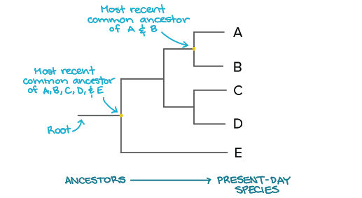Diagrams that show the proposed pathway of evolution, with branches indicating a different form/species of the organism has evolved from the ancestral form. Biochemical evidence has been important in producing accuracy in these trees

Natural selection

Adaptations: structural, physiological or behavioural characteristics which can help an organism to survive in a changing environment, eg: giraffe having a long neck to reach leaves on tall trees

Natural selection: the process whereby some organisms in a species have certain inherited variations/traits (adaptations) that give them an advantage over others. Only those organism that are best suited to an area or have advantageous characteristics pass these traits on to their offspring

* Can occur between different species within in a population or the same species
* This increases the proportion of favourable traits (they are selected for)
* A.K.A survival of the fittest
* It is only possible due to variation

Variation

* Sexual reproduction
  + Male and female parent information
  + Random assortment
  + Crossing over
* Mutations
  + Change in the base sequence of DNA to make a new protein
* Factors affecting populations such as immigration and emigration
* Selection acts on a variation that is already present

Allele frequency

* Natural selection causes a difference in the frequency of alleles
* This is how variation in a population can become dominant – the allele for the beneficial trait is slowly ‘spread’ through the population

Natural selection occurs because:

1. Genetic diversity
2. Selective pressure/environmental change
3. Difference in survival/reproduction success due to genetic differences
4. Changes in allele frequency

Evolution vs. natural selection

* Natural selection is a mechanism of evolution
* Takes place over generations, and observable
* Whereas evolution takes place over millions of years and not observable (by humans or even in time where humans existed)
* Involved genetic changes producing new/differences

Gene pool

* The genotype of all individuals capable of reproducing within a given population
* Studying the gene pool allows scientists to study how often an allele occurs within a population (allele frequency)

Allele frequency

* Measure of how often an allele occurs within a gene pool
* Allows determination of how often a characteristic will occur within a population
* Allele variation comes from ‘old mutations’
* Proportions of genes re generally the same from one generation to the next

Natural selection

* Allele frequencies will change over time
* In a small population, however, you get a random genetic drift occurring

Random genetic drift

* Non-directional and random variation in allele frequencies which occurs purely by chance
* 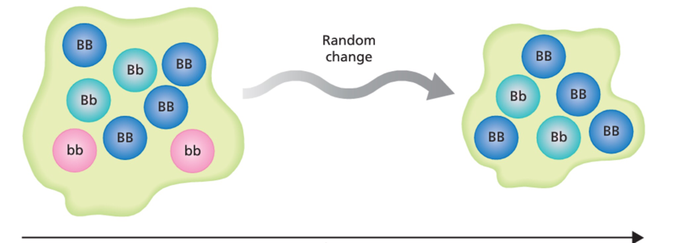Where one allele randomly becomes more dominant and has a greater chance of being passed on to the next generation within that population

Founder effect

* Small group moves away and isolates themselves
* 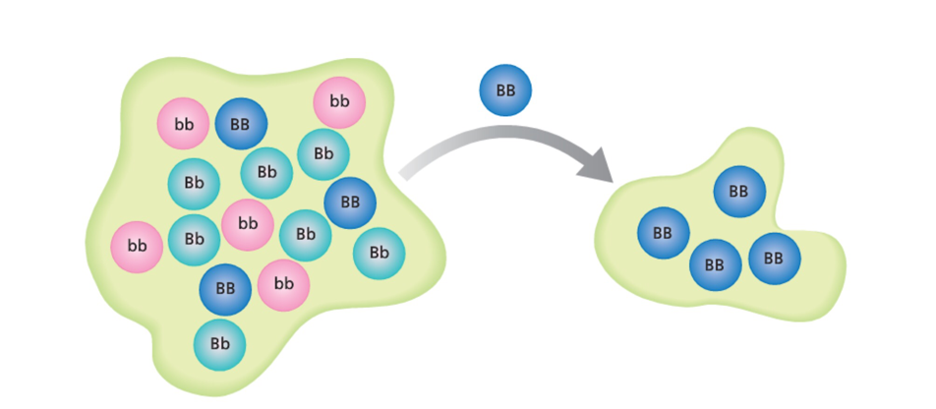New isolated population not true genetic representation of homeland

Bottle neck effect

* Occurs when population size significantly decreases due to disease, disaster, etc
* 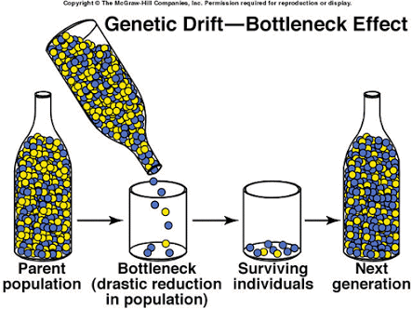Often interbreeding occurs

Barriers to gene flow

* Mechanical isolation: structural differences in the genitalia of 2 species
* Behavioural isolation: mating calls, nocturnal habits, etc
* Ecological isolation: different feeding niches, flowering times, etc
* Hybrid sterility: horse + donkey = mule (can’t breed)

Artificial selection

Artificial selection: the breeding of plants and animals to produce desirable traits in successive generations

Sexual selection: occurs when individual animals with certain inherited characteristics are more successful then other individuals in finding mates

Polyploidy and plant breeding

* Polyploids contain multiple sets of chromosomes
* Autopolyploids
  + Chromosomes from the same species
* Alloployploidy
  + Chromosomes from different species

Inbreeding and outbreeding

Outbreeding:

* Controlled selective reproduction between closely related individuals
* Outbreeding to introduce new and superior phenotypes, called hybrids

Inbreeding: to maintain desirable characteristics, may cause reduced fertility and lowered disease resistance, isn’t favoured

Protoplast fusion

* To produce hybrids in plants
* Two plant cells have cell walls removed by enzymes then fuse together the protoplasts to create a hybrid

Techniques with animals:

* Artificial insemination
* Embryo transplantation

Selection pressures

Environmental factors that influence the survival of an individual population or species

Competition: for food, water, territories

* Between individuals in a species
* Between different species

Predator prey relationships

Sexual selection

Speciation:

* The appearance of a new species, is marked by a clear biological boundary: the new species cannot successfully reproduce with the original species
* Relies upon reproductive isolation which prevents the gene pools of the new species from mixing with that of the original species
* Isolating mechanisms can separate two groups. These can be:
  + Pre-reproductive: (stop from reproducing)
    - Geographical features (seas, mountains)
    - Temporal mechanisms (different breeding seasons or time of day)
    - Behavioural mechanisms (different mating calls)
    - Morphological mechanisms (different reproductive structures)
  + Post-reproductive: (after reproduction, non viable offspring)
    - Gamete mortality (gametes do not survive after mating)
    - Zygote mortality (zygote forms but does not survive)
    - Hybrid sterility (adult offspring are infertile)
* Allopatric speciation occurs as a population are geographically isolated
* Sympatric speciation: evolution of 2 or more new species in the same place
* Eg: cicadas hatch out and reproduce once every 17 years and hatch every 13
* 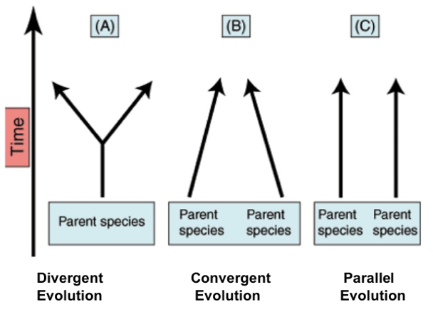This behaviour may have been the reproductive isolating mechanism that lead to their sympatric speciation

Microevolution and macroevolution

Microevolution

* Any change in the gene pool of a population which has been caused by natural selection
* Microevolution is any change in the gene pool of a population over time
* Regardless of how this change is occurring, if the gene pool

Macroevolution (rare)

* Major evolutionary changes above the species level are referred to as macroevolution
* It usually refers to more than one gene pool, or more than one species

Microevolution refers to small changes within a gene pool of a population

Macroevolution refers to evolutionary change affecting several gene pools

Macroevolution is rare, occurs after a major event like mass extinction

Principals of natural selection

1. Individuals within population show variation in their phenotypes
2. Much of this variation is due to different alleles and is therefore inheritable
3. Competition for resources and territories means there is a struggle for existence. More offspring are born that can survive and reproduce
4. Some individuals have traits that make them more suited to their environment than others

Extra biotech

Short tandem repeats (STRs)

* Non-coding DNA
* Pattern bases (2-5) eg: GAGAGA
* Isolated to put through PCR

Transition fossil: fossil that is closely related to its ancestor and its descendants, has qualities of both eg: Archaeopteryx

2 theories of evolution (speed)

* Gradualism
  + Steady, stable pace of evolution, transitional fossils are evidence for, shows the links
* Punctuated equilibrium
  + Happens spontaneous, under pressure, rapid
  + Eg: environmental pressure